SC-300-Identity-and-Access-Administrator
Lab 2 - Configure a Multifactor authentication registration policy
Lab scenario
Multifactor authentication provides a means to verify who you are using more than just a username and password. It provides a second layer of security to user sign-ins. For users to be able to respond to MFA prompts, they must first register for Microsoft Entra Multifactor Authentication. You must configure your Microsoft Entra organization’s MFA registration policy to be assigned to all users.
Exercise 1 - Set up MFA registration policy
Task 1 - Policy configuration
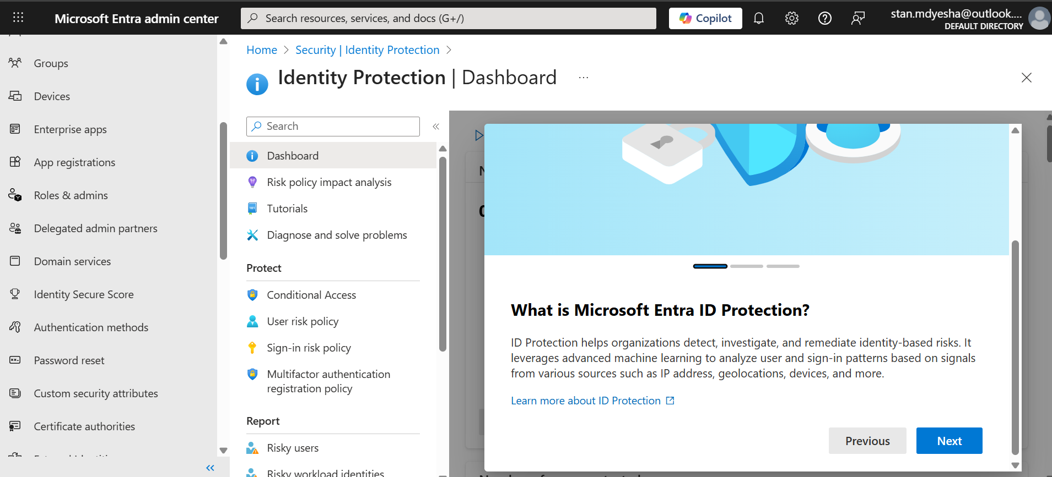
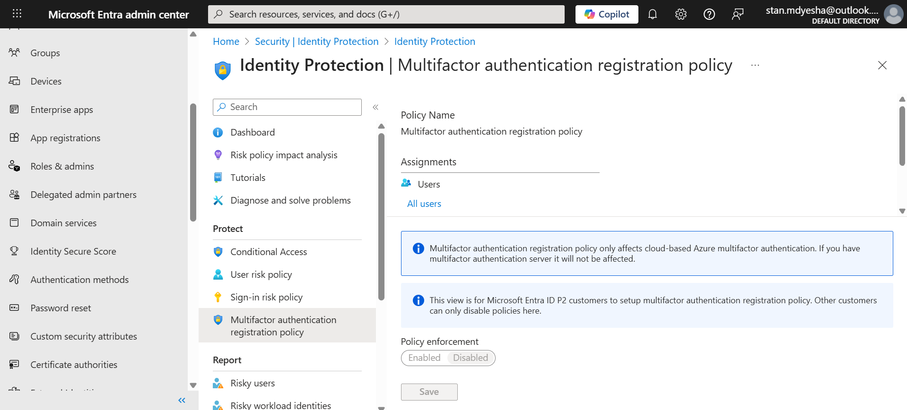

- Under Assignments, I selected All users and reviewed the available options.
- I can select from All users or Select individuals and groups if limiting the rollout.
- Additionally, I can choose to exclude users from the policy.
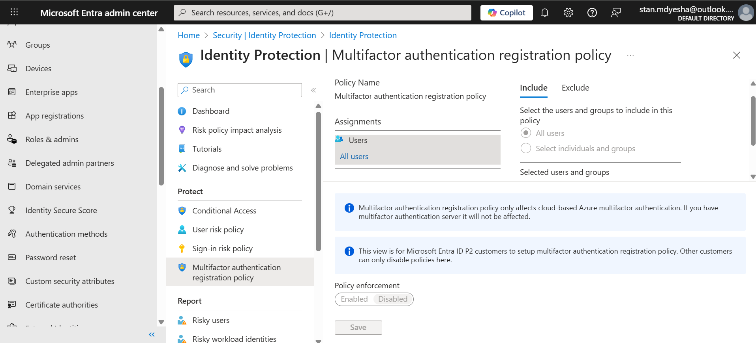
Task 2 - Configure Microsoft Entra Identity Protection policy for MFA registration
- In order to require the user to complete the MFA registration the next time they attempt to login. I had to do the following actions:
- Find the field Policy enforcement in the dialog. Set the value to Enabled.
- Select Save.
Note: Microsoft Entra Identity Protection requires Microsoft Entra ID Premium P2 to be activated.
Due to the above noted restriction. I could not enable the policy enforcement but I believe I’m well versed to carry-out this task.

